H.T No
Regulations:
A22

Sreenidhi Institute of Science and Technology
(An Autonomous Institution)
Code No:9AC42 Date: 09-August-2024 (FN)

B.Tech I-Year II- Semester External Examination, August-2024 (Regular & Supplementary)
ELECTRICAL CIRCUITS & NETWORK ANALYSIS (ECE)

Time: 3 Hours Max.Marks:60

Note: a) No additional answer sheets will be provided.
b) All sub-parts of a question must be answered at one place only, otherwise it will not be valued.
c) Missing data can be assumed suitably.
Bloom's Cognitive Levels of Learning (BCLL)

Remember | L1 | Apply | L3 | Evaluate | L5
Understand | L2 | Analyze | L4 | Create | L6

Part - A Max.Marks: 6x2=12

Answer all QUESTIONS, EACH QUESTION CARRIES 2 MARKS.

 |  | BCLL | CO(s) | Marks
1 | Design ideal voltage and current source transformation? | L4 | CO1 | [2M]
2 | Discuss the resonance in series circuit | L2 | CO2 | [2M]
3 | Compare the magnetic and electric circuit | L3 | CO3 | [2M]
4 | State Milliman’s theorem | L1 | CO4 | [2M]
5 | Develop the condition of reciprocity for Z Parameters? | L4 | CO5 | [2M]
6 | Define time constant of RC circuit | L1 | CO6 | [2M]

Part – B Max.Marks: 6x8=48
ANSWER ALL QUESTIONS. EACH QUESTION CARRIES 8 MARKS.

 |  | BCLL | CO(s) | Marks
7. | Find the mesh currents of the circuit shown in the following Figure  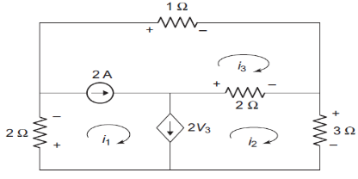 | L4 | CO1 | [8M]
 | OR
8 | Solve Mesh analysis, find V and I in the circuit below figure  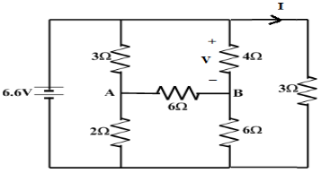 | L3 | CO1 | [8M]
9. | Derive the RMS and Average values of the sinusoidal waveform of AC supply. | L5 | CO2 | [8M]
 | OR
10 | Discuss the phasor diagram of series RLC circuit with sinusoidal excitation. Explain the relationship between different phasors. | L2 | CO2 | [8M]
11 | Write short notes on the following:  - Dot Convention.  - Concept of self and mutual inductance.  - Coefficient of coupling. | L1 | CO3 | [8M]
 | OR
12 | Find the value of XL in the coupled network shown in figure 1 for making it series resonant  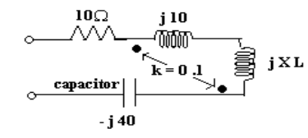 | L4 | CO3 | [8M]
13 | Explain superposition theorem, find ‘I’ in 6 ohm in the circuit below figure  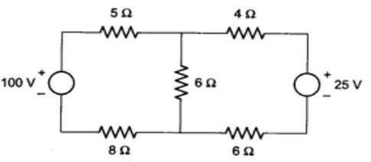 | L6 | CO4 | [8M]
 | OR
14 | Verify reciprocity Theorem for the following circuit shown in figure  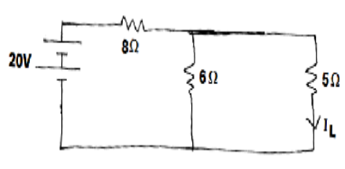 | L2 | CO4 | [8M]
15 | Solve the short circuit admittance parameters for the given network?  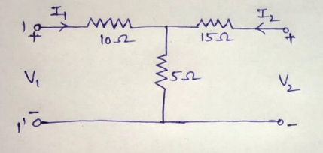 | L3 | CO5 | [8M]
 | OR
16 | The Z-parameters of a two- port network are Z11=15Ω, Z12=Z21=6Ω and Z22=24Ω. Determine ABCD parameters | L5 | CO5 | [8M]
17 | For R-L-C series circuit with D.C excitation discuss the under damped and over damped cases? | L4 | CO6 | [8M]
 | OR
18 | In the circuit shown in figure 4, determine the current in the inductor for t > 0. The switch is closed at t = 0.  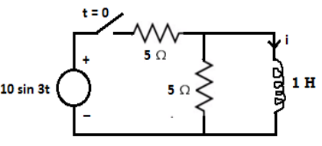 | L4 | CO6 | [8M]

-- 00 -- 00 –

